**Introductory Course in Chemical Engineering: Active Learning Strategies and the Adaptation to the Pandemic**

Lucimara Gaziola De La Torre1, Marco César Prado Soares1,2, Raphael Soeiro Suppino, Flávio Vasconcelos da Silva, Maria Teresa Moreira Rodrigues1

1School of Chemical Engineering, University of Campinas, Campinas, SP, Brazil

2School of Mechanical Engineering, University of Campinas, Campinas, SP, Brazil

E-mail: latorre@feq.unicamp.br

**Supporting Information**

Contents

1. Time spent with each activityS-2

2. Example of text written in the online forumS-3

3. Questions answered by the studentsS-4

4. Questions not shown in the main textS-5

5. Other examples of students’ webpagesS-6

6. Example of a block diagram obtained by a groupS-9

**1. Time spent with each activity**

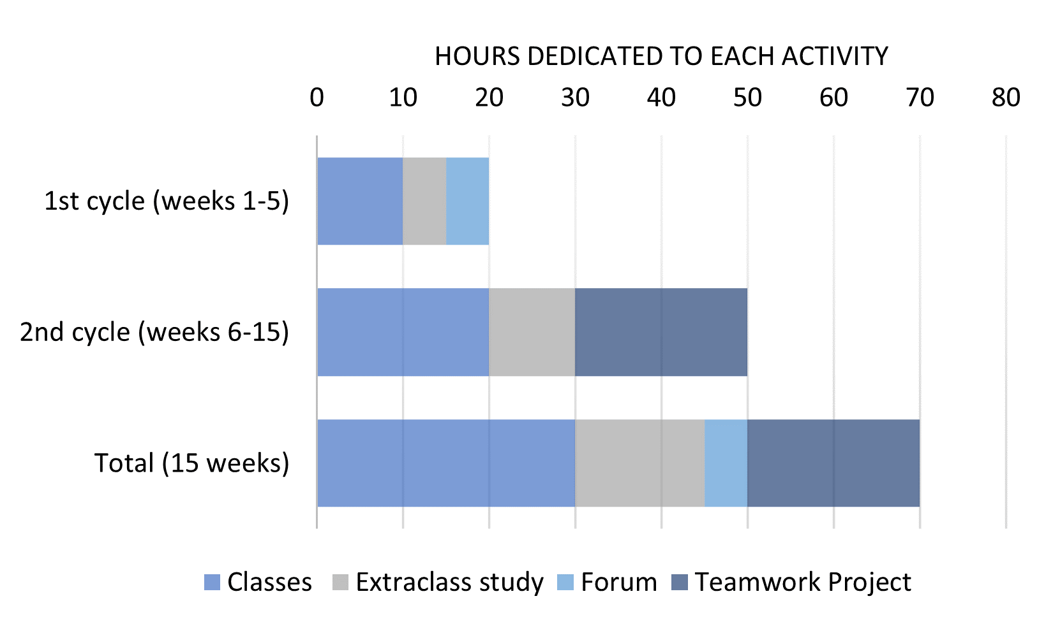

**Figure S1.** Time spent with each activity of the course.

**1. Example of text written in the online forum**



**Figure S2.** Example of a text written in the online forum (screenshot from the forum).

**2. Questions answered by the students**

Table S1 shows the full statements of the questionnaire answered by the 57 interviewed students. The table summarizes the number of students that choose each alternative, probability of agreeing with each statement, estimated uncertainty, and total of null answers. Data of Table S1 corresponds to the graphics shown in the main text.

Table S1. Questionnaire applied to the students. These data corresponds to the figures shown in the main text.

|  |  |  |  |  |  |
| --- | --- | --- | --- | --- | --- |
|  | | | **Total of Students:** | | **57** |
| **Statement** | **Alternatives** | **Results** | **Probability of Agreeing** | **Estimated Uncertainty** | **Null Answers** |
| The processes and chemical industries were presented and related to the other disciplines of the Chemical Engineering course. | Agree | 38 | 0.79 | 3 | 9 |
| Disagree | 10 |
| The course was effective in introducing the principles of technical writing, bibliographic research and plagiarism. | Agree | 41 | 0.85 | 2 | 9 |
| Disagree | 7 |
| The group works performed during the course helped in the development of other disciplines. | Agree | 27 | 0.63 | 3 | 14 |
| Disagree | 16 |
| The course contributed to keep me (student) motivated for the other disciplines. | Agree | 33 | 0.89 | 2 | 20 |
| Disagree | 4 |
| The remote synchronous classes contributed to the learning. | Agree | 22 | 0.88 | 2 | 32 |
| Disagree | 3 |
| The need for remotely performing the group works compromised the development of the course’s project. | Agree | 14 | 0.64 | 2 | 35 |
| Disagree | 8 |

**3. Questions not shown in the main text**

Table S2 shows other statements of the questionnaire answered by the 57 interviewed students, which were not included in the main text. Again, the table summarizes the number of students that choose each alternative, probability of agreeing with each statement, estimated uncertainty, and total of null answers.

Table S2. Questions not shown in the main text.

|  |  |  |  |  |  |
| --- | --- | --- | --- | --- | --- |
| **Statement** | **Alternatives** | **Results** | **Probability of Agreeing** | **Estimated Uncertainty** | **Null Answers** |
| The course was effective in presenting the challenges and the career of a Chemical Engineer. | Agree | 32 | 0.74 | 3 | 14 |
| Disagree | 11 |
| The remote classes during the social distancing period allowed the following and learning of the presented topics. | Agree | 25 | 0.86 | 2 | 28 |
| Disagree | 4 |
| The tools applied by the teaching staff like slides presentations and online meetings were enough for the conduction of the course. | Agree | 23 | 0.88 | 2 | 31 |
| Disagree | 3 |
| The availability of online collaborative tools helped the development of the course’s project. | Agree | 18 | 0.86 | 2 | 36 |
| Disagree | 3 |
| I (student) was both present and paying attention to all of the classes (not included the special classes for doubt removal). | Agree | 19 | 0.73 | 2 | 31 |
| Disagree | 7 |

**4. Other examples of students’ webpages**

Figures S3 to S5 show screenshots of the webpages developed and the videos recorded by two groups of students.



**Figure S3.** Screenshots of the webpage from a group of students who studied the process for producing phenol; (B) inset showing a photograph from this same website, illustrating the feeling of union developed throughout the project.



**Figure S4.** Screenshots of the (A) webpage; and (B) recorded video from a group of students who studied the process for producing optical fibers.



**Figure S5.** Screenshots of the (A) webpage; and (B) recorded video from a group of students who studied the process for producing paracetamol.

**5. Example of a block diagram obtained by a group**

Figures S6 illustrates a block diagram obtained by one of the groups, summarizing the production process of the glacial acetic acid.



**Figure S6.** Screenshot of the flow chart elaborated by a group which studied the production of the glacial acetic acid.